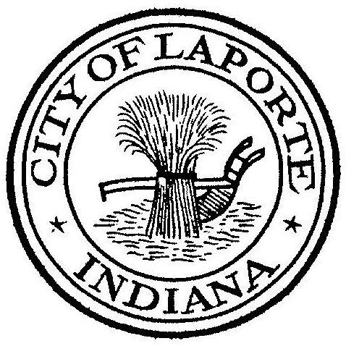
Board of Public Works and Safety
Jessica Romine, Member Tom Dermody, Mayor Mark Kosior, Member
City Hall 801 Michigan Ave., La Porte, IN 46350
Wednesday, November 6, 2024
9:00 AM
AGENDA
Live and archived transmissions are available at
https://www.facebook.com/cityoflaportein and https://www.youtube.com/cityoflaportein.
- Call To Order
- Pledge Of Allegiance
- Approval Of Minutes
- Public Comment: In Person and via Facebook Live
- Clerk-Treasurer: Claims Approval
-Fire Training Tower
- Department Head Reports
- New Business:
-Arnco Properties, LLC Infrastructure Reimbursement Agreement
- Unfinished Business:
- Other Business: Next regularly scheduled meeting: Tuesday, November 19, 2024 at 9a
- Adjourn

